Q2-1.

Z = 144 pins

I = 2048 Kbytes of Flash memory

T = LQFP

6 = Industrial temperature range, -40 to 85 degrees Celsius

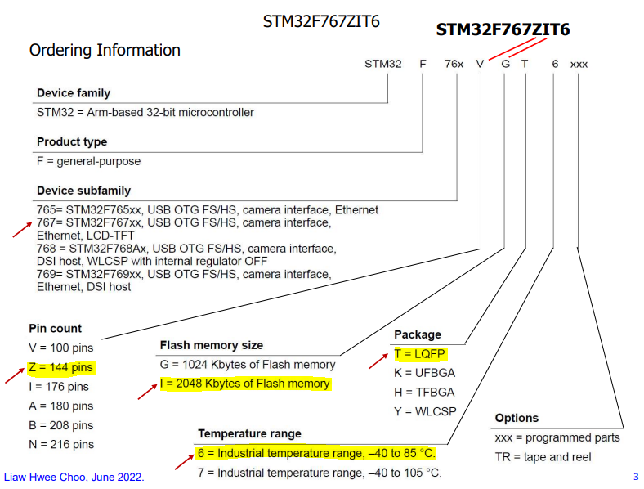

Q2-2. The allowable maximum current consumption by the Nucleo-F767ZI board when the U5V input is chosen is 500 mA.

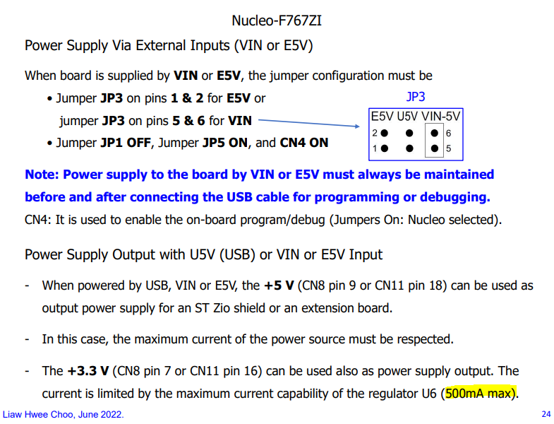

Q2-3.

Page 466/1954 from Ref_03_RM0410 Reference Manual_STM32F76xxx_R4_Mar2018.pdf

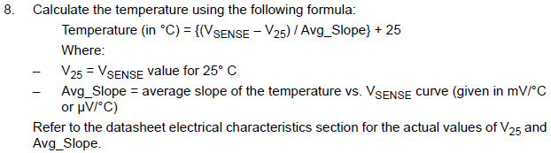

Page 168/252 from Ref_02-1_DS11532_Datasheet STM32F767xx_stm32f767zi_R7_Feb2021.pdf

